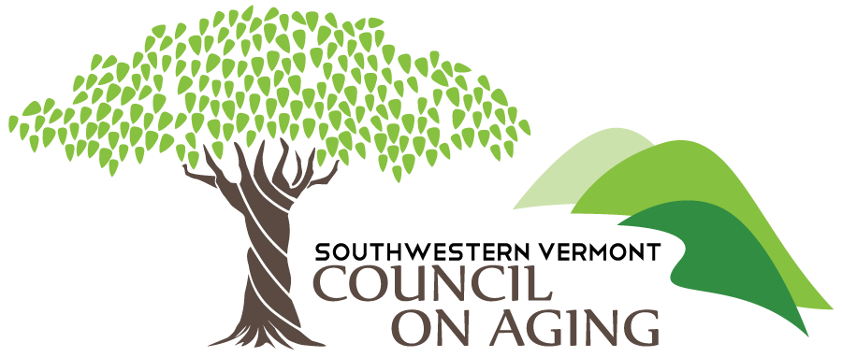

NATIONAL FAMILY CAREGIVER SUPPORT GRANT APPLICATION

FY 26
Oct 1, 2025 – Sept 30, 2026

Name of Organization/Individual: ___________________________________

Address: _______________________________________

_______________________________________

Phone Number: __________________________

Contact Person: _____________________________

Email: ______________________________

PLEASE PROVIDE THE FOLLOWING INFORMATION:

- Describe your organization, coalition or group (i.e. mission, etc.):

- Describe your proposed project:

- What are the goals of the proposed project?

- What steps will be needed to accomplish goals? (Please include timeframes)

- What grant amount are you requesting?

- Program Budget: Describe how you anticipate spending the funds, indicate any resources already available, e.g., space, other funding, volunteer time, etc. NOTE: An outline of the anticipated budget should be included.

- How will you evaluate your project? How will you know if you have achieved your goals? Note: keep in mind that SVCOA will include its own evaluation survey upon grant acceptance and this survey can suffice as means of program evaluation

- Do you plan on continuing the project after the grant is completed? If so, how?

NOTE: Please note that the grant period (SVCOA) is from October 1st, 2025 – September 30th, 2026 and a six-month report will be due by April 15th, 2026 as well as an end of year report which is due by October 15th, 2026. This will be outlined in the grant agreement and a template will be provided.

